NANYANG PRIMARY SCHOOL  
PRELIMINARY EXAMINATION 2019  
ENGLISH LANGUAGE

Be ATR RAPA AIRS TN ENE RT SPR TAPR PR a NT  
P - &§  
: PRIMARY 6  
  
(ere EE Ee eT

. PAPER 2: BOOKLET B

TOTAL TIME FOR BOOKLETS A & B: 1h 50 min

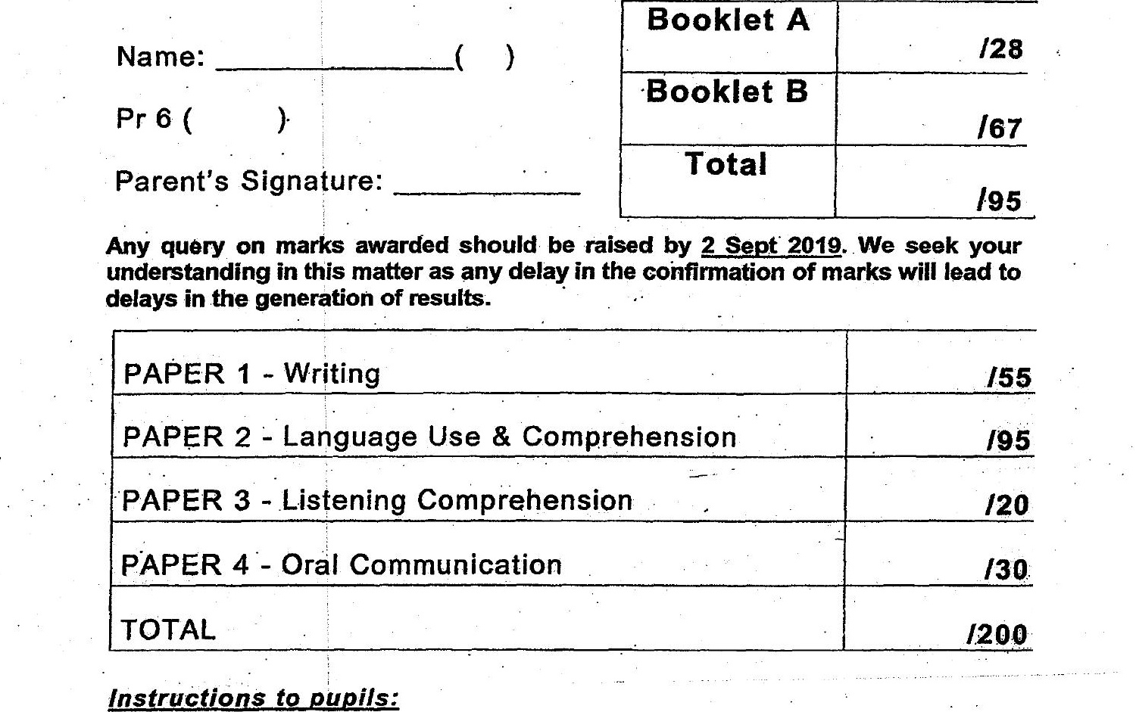

Pr 6 ( )

7. Do not turn over this page until you are told to do soa.  
2. Follow all instructions carefully.  
3. Answer all questions.